

Utility – Generate Access Report

SOLUTION DESIGN DOCUMENT

**Version: 1.0**



Revision History

The information contained in this document is the proprietary and confidential information of Blue Prism Limited and should not be disclosed to a third party without the written consent of an authorised Blue Prism representative. No part of this document may be reproduced or transmitted in any form or by any means, electronic or mechanical, including photocopying without the written permission of Blue Prism Limited.

**© Blue Prism Limited, 2001 - 2015**

All trademarks are hereby acknowledged and are used to the benefit of their respective owners.  
Blue Prism is not responsible for the content of external websites referenced by this document.

Blue Prism Limited, Centrix House, Crow Lane East, Newton-le-Willows, WA12 9UY, United Kingdom  
Registered in England: Reg. No. 4260035. Tel: +44 870 879 3000. Web: www.blueprism.com

|  |  |  |  |
| --- | --- | --- | --- |
| Date | Revision | Author | Description |
| 22-Feb-2019 | 1.0 | Michael Lowe | Initial version |

Contents

Revision History 2

1. Introduction 4

1.1. Robotic Resource Requirement 4

2. Solution Overview 5

2.1. Solution Diagram 5

2.2. Solution Description 5

3. Object Model 6

3.1. Object Model Diagram 6

4. Data Security and Credentials 7

4.1. Data Storage 7

4.2. Data Privacy 7

4.3. Credentials 7

5. Assumptions 8

5.1. Technical 8

# Introduction

This document describes the “Utility – Generate Access Report” Blue Prism® process and how it is built.

The process uses a custom VBO to generate details of users, roles and permissions from the specified Blue Prism connection. This information is then used to populate a spreadsheet template which is saved to a specified location.

## Robotic Resource Requirement

The process is not expected to be resource intensive and only requires a limited amount of processing time. It is therefor expected that no additional resources are needed to support this process.

# Solution Overview

The process uses an inbuilt template to generate an excel based report of users, roles and permissions. The location in which this file is stored is stored in an environment variable. The process is capable of working with both SSO and Blue Prism native authentication based environments.

## Solution Diagram

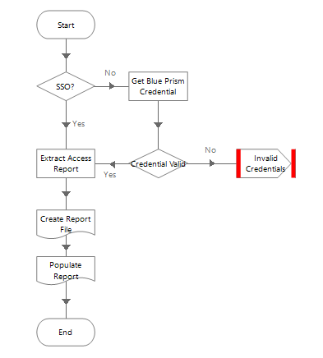

## Solution Description

The “Utility – Blue Prism Access Report” VBO is used to generate 3 collections of data around users, roles and permissions.

A template file is then saved to the resource and populated, saved and closed.

The final filepath of the report is passed out of the process in the event that this process is used as a sub process to send the report to external parties.

# Object Model

## Object Model Diagram

The below is the new object that was created to support this process.

|  |  |  |  |
| --- | --- | --- | --- |
| VBO | Action | Inputs | Outputs |
| Utility – Blue Prism Access Report | Generate Access Report | SSO (Flag)  Blue Prism Username (Text)  Blue Prism Password (Password)  Blue Prism Connection Name (Text)  Temp File Location (Text) | Roles/Permissions (Collection)  Users/Roles (Collection)  Available Permissions (Collection) |

**Standard Utility VBOs**

These are reused standard actions from the Blue Prism distribution. Note that these are not included in the distributed package.

|  |  |
| --- | --- |
| VBO | Action Used |
| MS Excel VBO | Activate Worksheet |
| Close Instance |
| Create Instance |
| Hide Worksheet |
| Open Workbook |
| Save Workbook |
| Set Cell Value |
| Write Collection |
| Utility – File Management | **Create Directory** |
| Write Binary Data |
| Internal - Credentials | **Get** |

# Data Security and Credentials

## Data Storage

A temporary files is used to store the raw access report text file. This file is then deleted once the contents are read into the process.

The logging is defined such that no user identifying information is stored in the session log files.

## Data Privacy

No user identifying information ins stored in the session logs.

## Credentials

If the environment is built using SSO then no credentials are required.

If the environment makes use of native authentication then a credential named “Blue Prism - User Report” is required. This is a Blue Prism user that must exist in the target environment. This user must also be active and have appropriate permission to create the audit report.

# Assumptions

## Technical

Microsoft Excel is installed on the target machine.